Project 01

Deploy a Database Server with Backup Automation
Objective: Automate the deployment and configuration of a PostgreSQL database server on an Ubuntu instance hosted on AWS, and set up regular backups.

Problem Statement
Objective: Automate the deployment, configuration, and backup of a PostgreSQL database server on an Ubuntu instance using Ansible.
Requirements:
- AWS Ubuntu Instance: You have an Ubuntu server instance running on AWS.
- Database Server Deployment: Deploy and configure PostgreSQL on the Ubuntu instance.
- Database Initialization: Create a database and a user with specific permissions.
- Backup Automation: Set up a cron job for regular database backups and ensure that backups are stored in a specified directory.
- Configuration Management: Use Ansible to handle the deployment and configuration, including managing sensitive data like database passwords.

Deliverables
- Ansible Inventory File
  - Filename: inventory.ini
  - Content: Defines the AWS Ubuntu instance and connection details for Ansible.

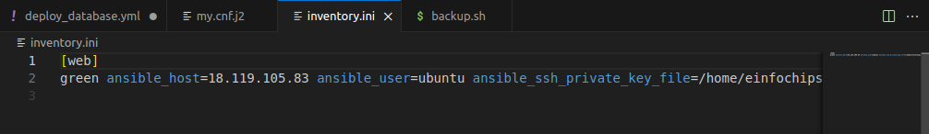

- Ansible Playbook
  - Filename: deploy_database.yml
  - Content: Automates the installation of PostgreSQL, sets up the database, creates a user, and configures a cron job for backups. It also includes variables for database configuration and backup settings.

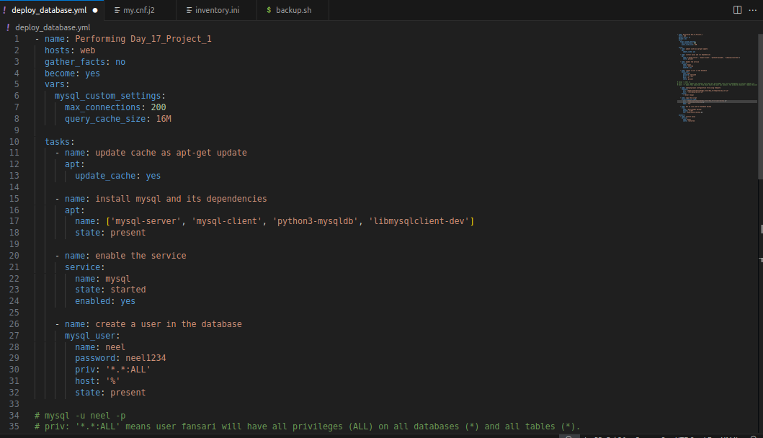

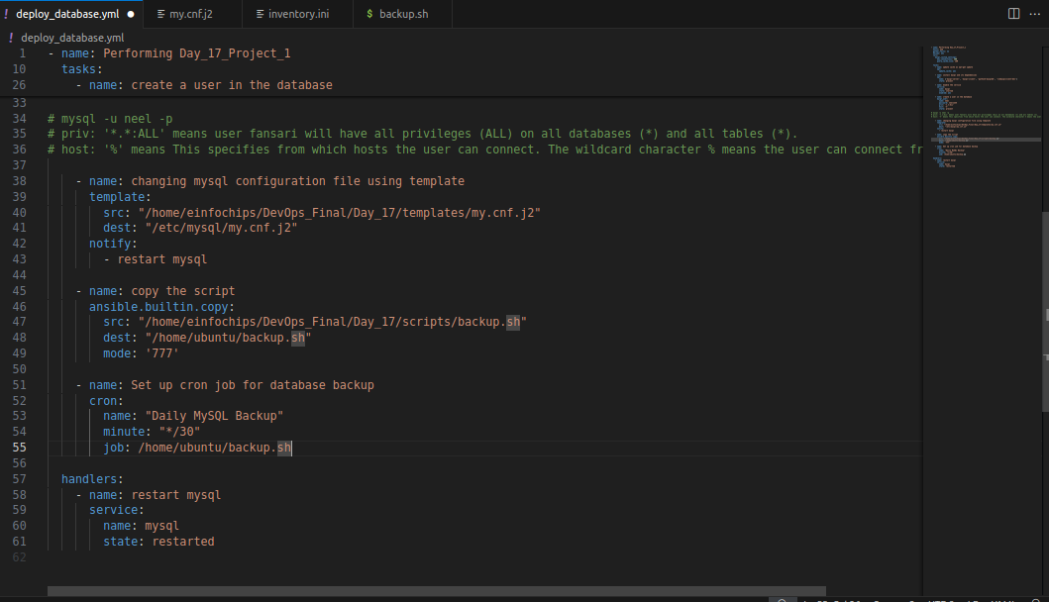

- Jinja2 Template
  - Filename: templates/pg_hba.conf.j2
  - Content: Defines the PostgreSQL configuration file (pg_hba.conf) using Jinja2 templates to manage access controls dynamically.

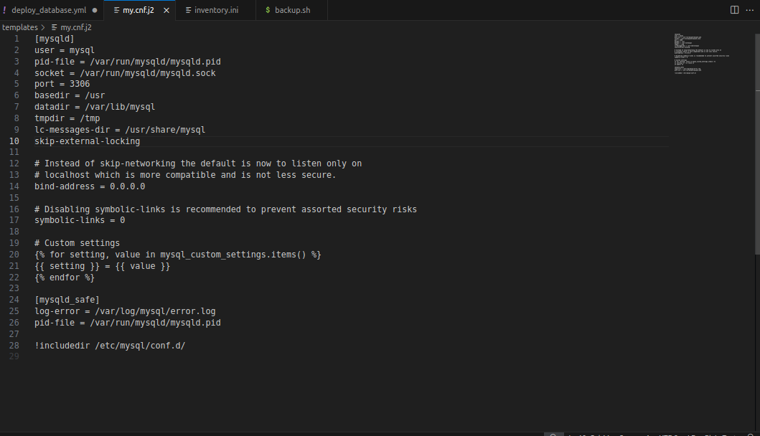

- Backup Script
  - Filename: scripts/backup.sh
  - Content: A script to perform the backup of the PostgreSQL database. This script should be referenced in the cron job defined in the playbook.

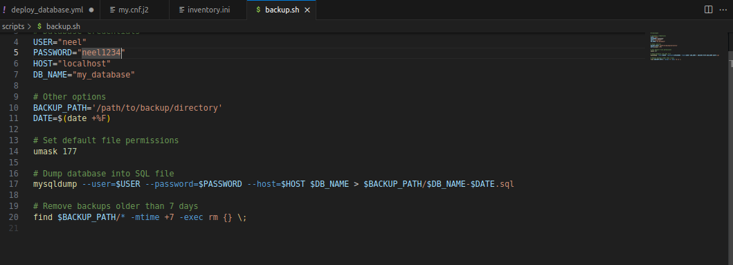

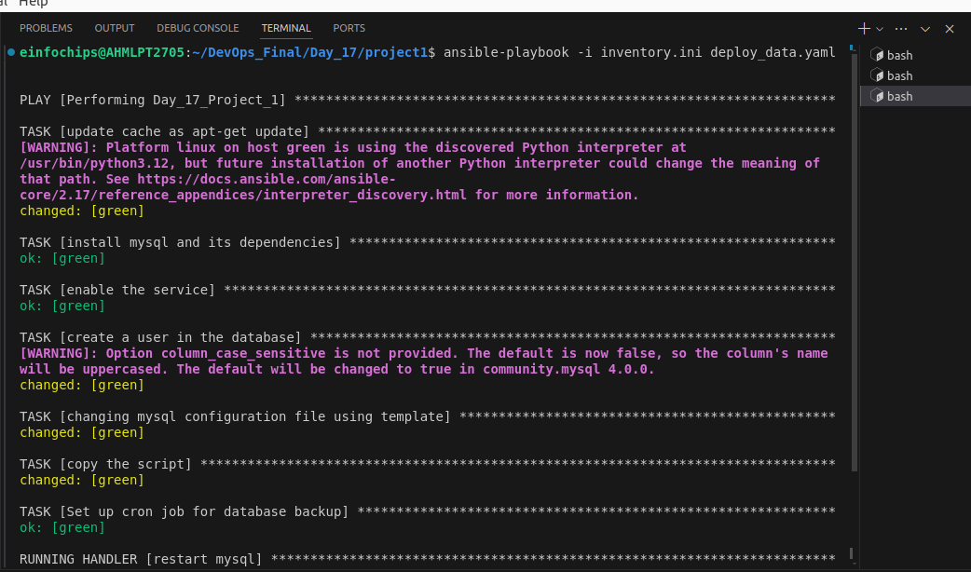

Project 02
Objective: Automate the setup of a multi-tier web application stack with separate database and application servers using Ansible.

Problem Statement
Objective: Automate the deployment and configuration of a multi-tier web application stack consisting of:
- Database Server: Set up a PostgreSQL database server on one Ubuntu instance.
- Application Server: Set up a web server (e.g., Apache or Nginx) on another Ubuntu instance to host a web application.
- Application Deployment: Ensure the web application is deployed on the application server and is configured to connect to the PostgreSQL database on the database server.
- Configuration Management: Use Ansible to automate the configuration of both servers, including the initialization of the database and the deployment of the web application.

Deliverables
- Ansible Inventory File
  - Filename: inventory.ini
  - Content: Defines the database server and application server instances, including their IP addresses and connection details.

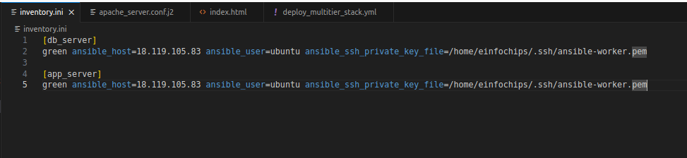
- Ansible Playbook
  - Filename: deploy_multitier_stack.yml
  - Content: Automates:
    - The deployment and configuration of the PostgreSQL database server.
    - The setup and configuration of the web server.
    - The deployment of the web application and its configuration to connect to the database.

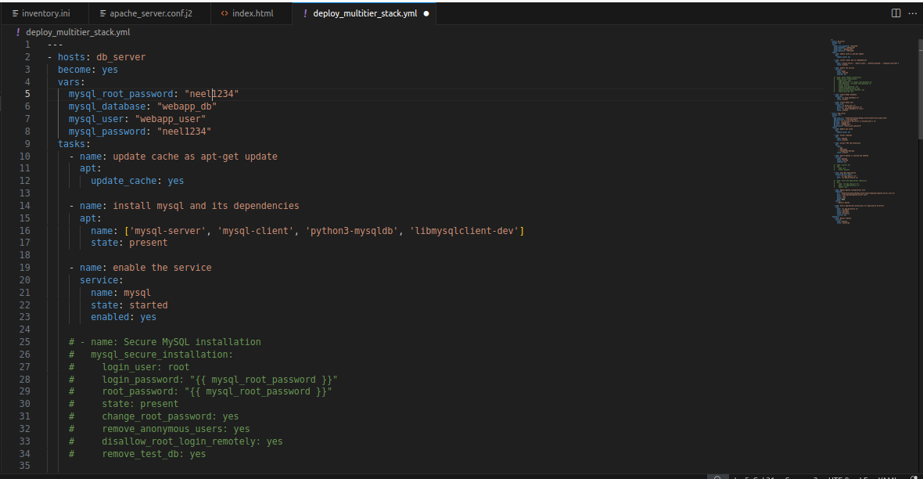

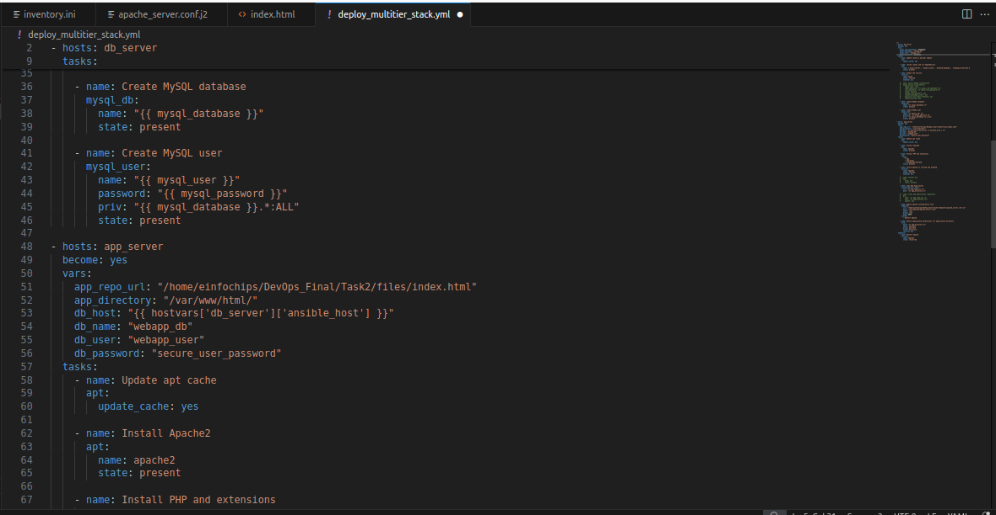

- Jinja2 Template
  - Filename: templates/app_config.php.j2
  - Content: Defines a configuration file for the web application that includes placeholders for dynamic values such as database connection details.

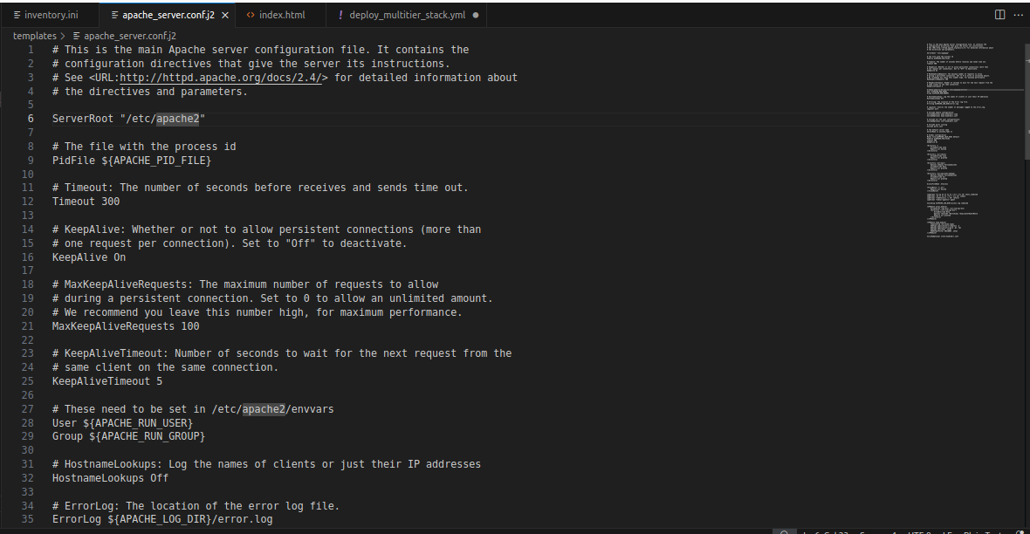

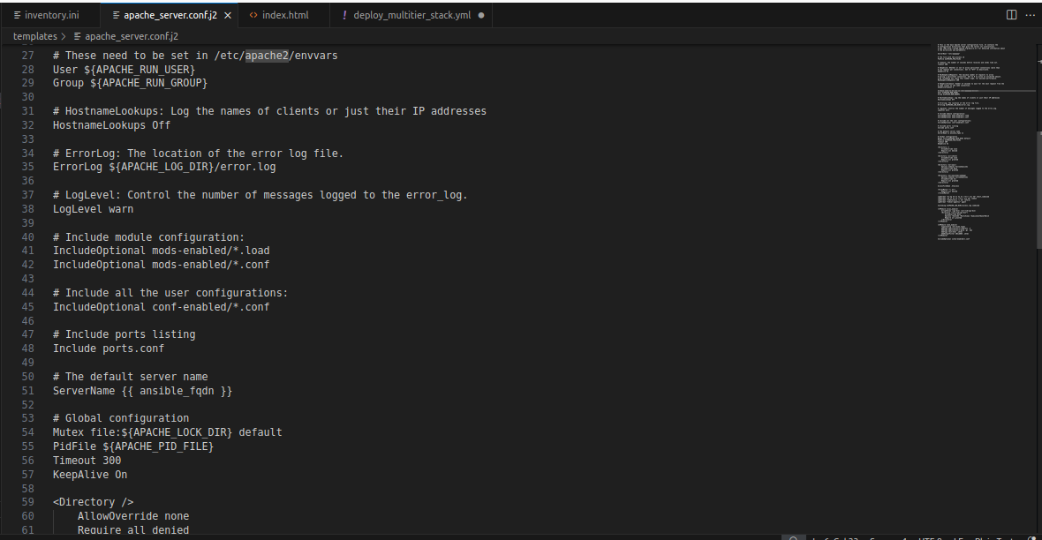

- Application Files
  - Filename: files/index.html (or equivalent application files)
  - Content: Static or basic dynamic content served by the web application.

